<!DOCTYPE html>

<html lang="en">

<head>

<meta charset="UTF-8">

<meta name="viewport" content="width=device-width, initial-scale=1.0">

<title>Wayne Hotel - Home</title>

<link rel="stylesheet" href="styles.css">

<style>

img {

max-width: 80%; /* Adjust this value as needed */

height: auto;

border-radius: 10px;

display: block;

margin: 0 auto; /* Center the image horizontally */

}

</style>

</head>

<body>

<header>

<nav>

<ul>

<li><a href="index.html">Home</a></li>

<li><a href="rooms.html">Rooms</a></li>

<li><a href="facilities.html">Facilities</a></li>

<li><a href="contact.html">Contact Us</a></li>

</ul>

</nav>

<h1>Welcome to Wayne Hotel</h1>

</header>

<section>

<h2>About Us</h2>

<p>Wayne Hotel is your perfect getaway destination. Experience luxury and comfort with our world-class facilities.</p>

<img src="D:\Wayne Hotel\DALL·E 2024-08-18 19.59.07 - A luxurious and welcoming hotel entrance named 'Wayne Hotel'. The entrance features a grand, elegant design with large glass doors, warm lighting, and.webp" alt="Hotel Entrance">

</section>

<footer>

<p>&copy; 2024 Wayne Hotel. All rights reserved.</p>

</footer>

</body>

</html>

<!DOCTYPE html>

<html lang="en">

<head>

<meta charset="UTF-8">

<meta name="viewport" content="width=device-width, initial-scale=1.0">

<title>Wayne Hotel - Rooms</title>

<link rel="stylesheet" href="styles.css">

</head>

<body>

<header>

<nav>

<ul>

<li><a href="index.html">Home</a></li>

<li><a href="rooms.html">Rooms</a></li>

<li><a href="facilities.html">Facilities</a></li>

<li><a href="contact.html">Contact Us</a></li>

</ul>

</nav>

<h1>Our Rooms</h1>

</header>

<section>

<table>

<tr>

<th>Room Type</th>

<th>Price per Night</th>

</tr>

<tr>

<td>Deluxe Suite</td>

<td>R.1000</td>

</tr>

<tr>

<td>Executive Room</td>

<td>R.1800</td>

</tr>

<tr>

<td>Standard Room</td>

<td>R.2000</td>

</tr>

</table>

</section>

<footer>

<p>&copy; 2024 Wayne Hotel. All rights reserved.</p>

</footer>

</body>

</html>

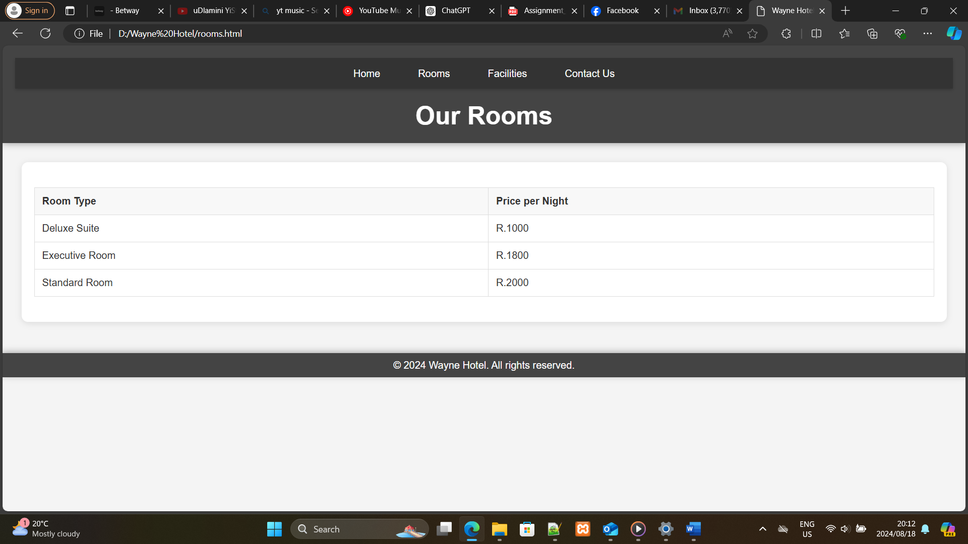

<!DOCTYPE html>

<html lang="en">

<head>

<meta charset="UTF-8">

<meta name="viewport" content="width=device-width, initial-scale=1.0">

<title>Wayne Hotel - Facilities</title>

<link rel="stylesheet" href="styles.css">

<style>

.gallery {

display: flex;

flex-direction: column;

align-items: center;

gap: 10px;

}

.gallery img {

width: 300px; /* Ensures all images have the same width */

height: auto;

cursor: pointer;

}

/* Lightbox overlay style */

.lightbox {

display: none;

position: fixed;

z-index: 999;

left: 0;

top: 0;

width: 100%;

height: 100%;

background-color: rgba(0, 0, 0, 0.8);

justify-content: center;

align-items: center;

}

.lightbox img {

max-width: 90%;

max-height: 90%;

}

.lightbox:target {

display: flex;

}

</style>

</head>

<body>

<header>

<nav>

<ul>

<li><a href="index.html">Home</a></li>

<li><a href="rooms.html">Rooms</a></li>

<li><a href="facilities.html">Facilities</a></li>

<li><a href="contact.html">Contact Us</a></li>

</ul>

</nav>

<h1>Our Facilities</h1>

</header>

<section>

<h2>Facilities Offered</h2>

<ul>

<li>Spa and Wellness Center</li>

<li>Swimming Pool</li>

<li>Fitness Center</li>

<li>Gourmet Restaurant</li>

</ul>

<h3>Gallery</h3>

<div class="gallery">

<a href="#img1"><img src="D:\Wayne Hotel\OIP (1).jpeg" alt="Facility Image 1"></a>

<a href="#img2"><img src="D:\Wayne Hotel\OIP.jpeg" alt="Facility Image 2"></a>

<a href="#img3"><img src="D:\Wayne Hotel\R (1).jpeg" alt="Facility Image 3"></a>

<a href="#img4"><img src="D:\Wayne Hotel\R.jpeg" alt="Facility Image 4"></a>

</div>

<!-- Lightbox containers -->

<div id="img1" class="lightbox">

<a href="#"><img src="D:\Wayne Hotel\OIP (1).jpeg" alt="Facility Image 1"></a>

</div>

<div id="img2" class="lightbox">

<a href="#"><img src="D:\Wayne Hotel\OIP.jpeg" alt="Facility Image 2"></a>

</div>

<div id="img3" class="lightbox">

<a href="#"><img src="D:\Wayne Hotel\R (1).jpeg" alt="Facility Image 3"></a>

</div>

<div id="img4" class="lightbox">

<a href="#"><img src="D:\Wayne Hotel\R.jpeg" alt="Facility Image 4"></a>

</div>

</section>

<footer>

<p>&copy; 2024 Wayne Hotel. All rights reserved.</p>

</footer>

</body>

</html>

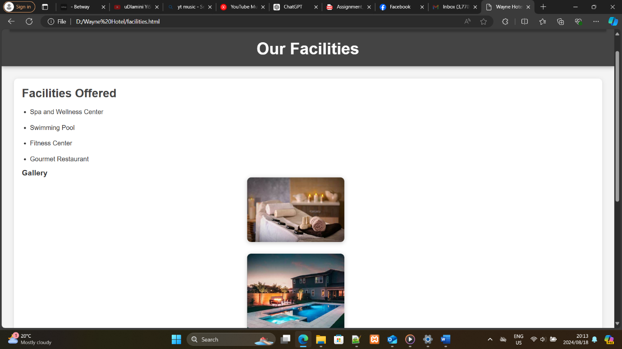

<!DOCTYPE html>

<html lang="en">

<head>

<meta charset="UTF-8">

<meta name="viewport" content="width=device-width, initial-scale=1.0">

<title>Wayne Hotel - Contact Us</title>

<link rel="stylesheet" href="styles.css">

</head>

<body>

<header>

<nav>

<ul>

<li><a href="index.html">Home</a></li>

<li><a href="rooms.html">Rooms</a></li>

<li><a href="facilities.html">Facilities</a></li>

<li><a href="contact.html">Contact Us</a></li>

</ul>

</nav>

<h1>Contact Us</h1>

</header>

<section>

<h2>Get in Touch</h2>

<form action="submit_form.php" method="post">

<label for="name">Name:</label>

<input type="text" id="name" name="name" required>

<label for="email">Email:</label>

<input type="email" id="email" name="email" required>

<label for="message">Message:</label>

<textarea id="message" name="message" rows="5" required></textarea>

<input type="submit" value="Send Message">

</form>

</section>

<footer>

<p>&copy; 2024 Wayne Hotel. All rights reserved.</p>

</footer>

</body>

</html>

* {

margin: 0;

padding: 0;

box-sizing: border-box;

}

body {

font-family: 'Arial', sans-serif;

background-color: #f4f4f4;

color: #333;

}

header {

background-color: #444;

color: white;

padding: 20px;

text-align: center;

box-shadow: 0 2px 10px rgba(0, 0, 0, 0.3);

}

nav ul {

list-style-type: none;

padding: 0;

display: flex;

justify-content: center;

background-color: #333;

box-shadow: 0 2px 5px rgba(0, 0, 0, 0.2);

}

nav ul li {

margin: 0 15px;

}

nav ul li a {

color: white;

text-decoration: none;

padding: 10px 15px;

display: block;

transition: background-color 0.3s;

}

nav ul li a:hover {

background-color: #555;

border-radius: 5px;

}

h1 {

margin-top: 20px;

font-size: 2.5em;

}

section {

margin: 30px;

padding: 20px;

background-color: white;

border-radius: 10px;

box-shadow: 0 2px 10px rgba(0, 0, 0, 0.1);

}

section h2 {

margin-bottom: 15px;

font-size: 1.8em;

color: #444;

}

section p {

margin-bottom: 20px;

line-height: 1.6;

}

footer {

background-color: #444;

color: white;

text-align: center;

padding: 10px 0;

position: relative;

bottom: 0;

width: 100%;

margin-top: 50px;

box-shadow: 0 -2px 10px rgba(0, 0, 0, 0.3);

}

/* Table styling */

table {

width: 100%;

border-collapse: collapse;

margin: 20px 0;

border: 1px solid #ddd;

}

table, th, td {

border: 1px solid #ddd;

text-align: left;

}

th, td {

padding: 12px;

font-size: 1em;

}

th {

background-color: #f8f8f8;

}

/* Form styling */

form {

margin: 20px 0;

}

label {

display: block;

margin-bottom: 5px;

font-weight: bold;

}

input, textarea {

width: 100%;

padding: 10px;

margin-bottom: 15px;

border: 1px solid #ddd;

border-radius: 5px;

font-size: 1em;

}

input[type="submit"] {

background-color: #444;

color: white;

border: none;

padding: 12px 20px;

border-radius: 5px;

cursor: pointer;

transition: background-color 0.3s;

}

input[type="submit"]:hover {

background-color: #333;

}

/* Image and list styling */

.gallery {

display: flex;

flex-direction: column;

align-items: center;

}

.gallery img {

max-width: 80%;

margin-bottom: 15px;

border-radius: 10px;

box-shadow: 0 2px 10px rgba(0, 0, 0, 0.2);

}

ul {

list-style-type: disc;

padding-left: 20px;

line-height: 1.8;

}

ul li {

margin-bottom: 10px;

}